POssible Astronomical Intentionality in the neolithic mnajdra south temple in malta

Tore LOmsdalen

Abstract: Suggestions of astronomical consideration and intentionality behind the architecture of the Neolithic Mnajdra South Temple is conducted through field studies, observations and researching relevant literature and publications. The research is founded on the temple’s orientation, on cross-jam view and off-set illumination of sunrise at equinox, summer and winter solstice. The question of sacred rituals related to specific times or seasonal periods by observing the suns annual path on the eastern horizon, is investigated as a possibility of intentionality for the temples orientation and structure. Demarcated areas of the temple are illuminated at sunrise throughout the year, and especially pronounced at the beginning of modern times’ ingress to the cardinal seasons. Of the extant prehistoric temples on Malta, The Mnajdra South Temple is the only one with an evident orientation towards East which coincides with both the sunrise at Equinox and during the temple period, the heliacal rising of the Pleiades.
Keywords: Archaeoastronomy, Malta, Temples, Orientation, Horizon Astronomy, Intentionality

Introduction
Clive Ruggles (2010) said that ‘Around the world we have many sites that are aligned on equinox or solstice sunrise, like Stonehenge. But there are only two sites known in the world, that I’m aware of, where you have a device that seems to cover a whole arc. They’ve both been discovered in the last 5 years or so. One is Taosi in China and the other Chankillo in Peru’ (although Malville (2011:154) questions this claim for Chankillo). This paper argues the case that the Mnajdra South Temple might be a third site qualifying as a “device that seems to cover” the path of the sun throughout the year. It is worth noting that the Mnajdra South compound was built around 3600 - 3000 BC, (Pace 2004a:18) thus predating Taosi by about one and Chankillo by about two millennia. The first survey of the orientations of the Maltese temples and their astronomical significance goes back to Agius and Ventura (1980) in the 1970s/80s.

According to Michael Kolb (2008: 158) the monuments of the Maltese islands predate any other built in the Mediterranean and represent some of the earliest monuments ever built (Renfrew 2007: 49). On the question of whether these monuments were temples or not, Giulio Magli (2009: 49) maintains that ‘there are no written sources to support this assumption, and all the evidence we have on the function of these structures is circumstantial’. Although Magli’s statement might be correct in its own context, most scholars researching the monuments seem to accept them as temples, as confirmed by Christopher Tilley who stated: ‘That these were temples, or ritual monuments, is beyond doubt’ (Tilley 2004: 92). The first mention of the monuments as temples goes back to Francesco Abela (1647: 145) who in 1647 claimed they were built by giants. Themistocles Zammit (1929:46), the first major excavator of the temples in 1910’s and 20’s, used the denomination of Megalithic Sanctuaries. David H. Trump (1972: 24), a more recent authority on Maltese archeology, refers frequently to the monuments as ‘Temples’. Robin Skeates (2010: 156) suggests, ‘they probably did function, at least in part, as sacred places for worship’.

What is generally known as the Maltese Temple Period occurred around a millennium after the first settlers came from Sicily around 5000 BC (Trump 2002: 23). The temple culture lasted for about another one and a half millennia, then suddenly went into an inexplicable decline for no apparent reason (Magli 2009: 48-9). How and why this culture came to an end and why nothing survived from the temple period apart from the megalithic structures themselves, is as much a mystery as is how and why it all began. The succeeding Bronze Age population had nothing like the masonry and architectural skills and abilities of their Neolithic predecessors (Magli 2009: 49). The early immigrants maintained some contact with Sicily and beyond, however, they pursued their own culture, (Trump 1972: 20) and around 4000 BC the ceramic repertoire changed completely, suggesting a change in culture (Bonanno 2011: 154).

Temple Lay-out and Architecture
A prominent striking feature of the pre-historic Maltese temples is the curvaceousness of their walls. It is hard to find an ordinary corner anywhere as chambers and apses are arranged in semi-circles appearing as clover leaves with a central corridor as the stem. What seems to be intentionally constructed as a rectangular space is the niche of the altar, centrally erected in the temple hallway or in one of the apses. The question whether the temples were roofed remains highly contentious, but there is evidence that they were (see (Trump 2002: 192) and (Pace 2004b: 85)). Being roofed, the sensory experience of the sun’s illumination of demarcated areas inside the temple, would be highly incremented.

Mnajdra was first excavated in 1840 without any adequate reports (Evans 1971: 3) and the temple complex consists of three distinct structures (Fig. 1 (Evans 1971: Plan 20A)), however, the precise building chronology is n difficult to establish (Pace 2004b: 128). The smallest, a trefoil layout, is according to Evans (1971: 103) and Trump (1997: 100) the oldest and dates from the Ggantija phase (3600-3250 BC). The five-lob middle temple, the largest one, was the last to be built sometime after 3100 BC (early Tarxien phase). The lower, four apse, Mnajdra South Temple seemingly has various construction phases starting from later Ggantija to early Tarxien periods (Evans 1971: 102; Trump 1997: 101).
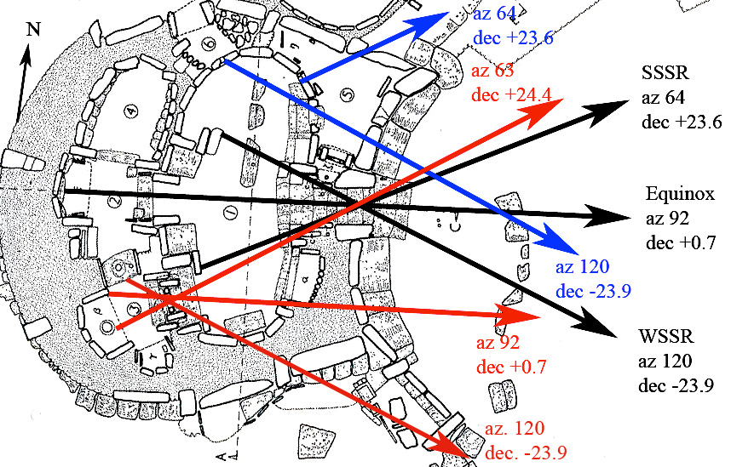

Figure 1. Mnajdra South Temple complex plan with measured orientations marked. The black arrows indicate the main apsis alignments with the Solstices and Equinoxes. The blue and red arrows indicate other alignments, discussed in the text, respectively the oracle holes and room 3.

Evans (1971: 103) suggests rooms 2 and 3 are the oldest parts of the temple. Trump (1972: 102) claims the pitted porthole entrance to room 3 to be the centre interest in the first left apse. According to site observations, this arrangement looks strikingly like a temple entrance in its own right. Inside, there are two double pillar altars and one single pillar altar which makes the separation to room 2. The placement of the altar hampers any easy access between the two rooms, however, it might have been used for communication or as a unified altar for both rooms. Similar tea-tray top altars are to be found at the Hagar Qim temple, Mnajdra’s next door neighbour. Pace (2004b: 131) suggests that room 3 ‘is an older apse internally refurbished.’ It is thus suggested that room 3 might actually be the oldest and the original part of the whole Mnajdra South Temple complex, but there is no archaeological evidence to support such a theory.

The first right-hand apse (room 1) has what is commonly known as two oracle holes (Trump 2002: 150), one with an entrance from the outside (room 6) and the other reachable through a porthole entrance in the apse wall itself (room 5). Another remarkable feature of this temple is what seems to be an altar centrally placed at the end of the main corridor about 15 meters from the entrance. This altar is illuminated by the first rays of the rising sun over the eastern horizon at the spring and autumn equinoxes (Fig. 2), when the light actually never reaches above a horizontal slab placed as a top table of the altar itself (Campion and Malville 2011: 360-1).

Temple Orientation and Astronomy
Temples and temple complexes are themselves found in a number of clusters that might have formed distinct communities within various centers on Gozo and Malta (Cox and Lomsdalen 2010), and most are in the range south-east to south-west orientation (Cox and Lomsdalen 2010). Cox (2001: 36) proposes that the orientations of the temples of Gozo and Malta show consistency of bearing that suggests some temples might intentionally have been constructed to face particular directions. Agius and Ventura (1980: 9) carried out a statistical analysis of the azimuth orientation axes of 26 temples, using a chi-square test in 1980. They maintained that the probability that the builders did not have any preference for any particular direction is less than 1 in a 1000. Based on new research (Fodera Serio et al., 1992: 109) they were left with 14 temple axes (excluding Mnajdra South) and found them all within a range from 125.5° to 204°, which is less than a quadrant of a circle. They concluded their findings stating that ‘Such a concentration of axes cannot have come about by chance.’ (Fodera Serio et al. 1992: 116-7).

In Malta, evidence of Neolithic interest in celestial observation is found in artistic representations of stars and a crescent moon (Ridley 1976: 67), a possible ‘solar wheel’ (Ventura 2004: 312), a possible representation of the constellation of the Southern Cross (Zammit 1929: 13 and Aguis and Ventura 1980: 20) and a bull with thirteen sucklings motif that Campion (2008: 21) suggests might be associated with the 13 lunar months and represent the constellation of the Pleiades. Furthermore, Ventura (1993: 176) maintains that the Pleiades was rising at a declination around 0°, that is an azimuth of 90°, due east, at the time of the temple period. The field research established that the slabs in the Tarxien temple where the bulls in question were engraved do have an East/West alignment. Whether this is by chance or intentionally aligned with the Pleiades, is a question of speculation, nevertheless, an interesting coincidence. The oldest temple of the Mnajdra compound, the small three foil one, has, according to Ventura et al. (1993: 179), a tally stone indicating the sequence of heliacal risings of stars and star groups that correspond to the number of drilled

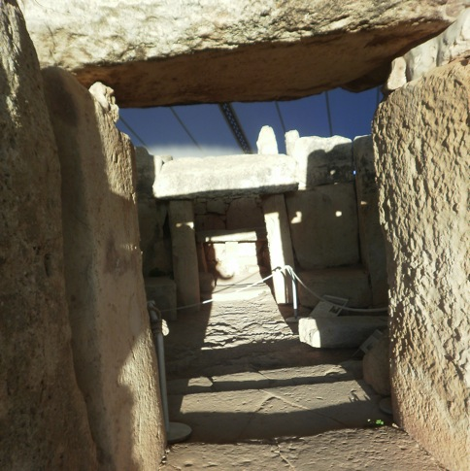
Figure 2. Mnajdra South Temple illumination of the central altar during sunrise at the Equinox.

holes in each row on the east pillar, starting with the observation of the heliacal rising of the Pleiades. Mario Vassallo (2000) who has conducted celestial observations of Ta’Hagerat, Skorba, Ggantija South and North, Hagar Qim and Mnajdra over the last 15 years, concludes that their main entrances are aligned to the winter solstice sunrise in a diagonal, cross-jamb illumination. In a later study, Vassallo (2011) and Albrecht (2004) describes the Hagar Qim Temple as a construction where the rising and setting of the sun on equinox and the solstices could have influenced the positioning of the megaliths and the orientation of the structure itself. During field studies conducted in 2010 and 2011, the author’s observations of the offset illuminations from the temple entrances led to conclusions similar to Vasallo’s.

The Mnajdra South Temple and Astronomy
Out of all the extant temples in Malta, Mnajdra South (MNS) is apparently the only one with a clearly defined eastern orientation and has a ‘perfect’ alignment towards the Spring and Autumn Equinox when the sun appears on the horizon illuminating the main passage (Agius and Ventura 1981: 14). Nevertheless, Agius and Ventura conclude that despite this, the temple might be oriented by chance since during the equinox the rising and setting position of the sun are most difficult to establish and there is no evidence that the temple architects knew these directions. A deliberate eastern orientation could be found by bisecting the position of the midsummer and midwinter sunrise (Fodera Serio et al. 1993: 172-3; Cox and Lomsdalen 2010), which would have been aided by the presence of markers in, for example, postholes. In order to find astronomical intentionality behind MNS’s eastern orientation, Ventura in collaboration with Agius conducted in 1979-80 a search for any evidence of postholes in the local landscape which could have determined the alignment to the summer and the winter solstices, as seen from Mnajdra. Two apparently human-made holes were found, although it seems difficult to date them. One seemingly aligned to the winter solstice sunrise (WSSR) as seen from the entrance to MNS, and the other was about 3° south of the summer solstice sunrise (SSSR) (Aguis and Ventura 1980: 173-6). As mentioned, in the period of 3,000 BCE, the eastern orientation would have coincided with the rising point of the Pleiades, and would have seen the heliacal rising of this star group close to the time of the spring equinox (Ventura et al. 1993: 181; Hoskin 2001: 34-6; Ventura 2004: 321; Cox and Lomsdalen 2010).

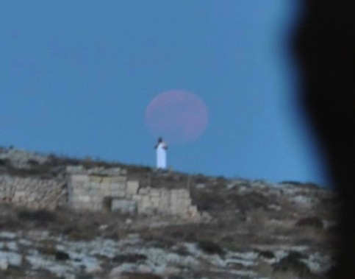
Figure 3. Picture taken from inside the Mnajdra South Temple, through the entrance’s cross-jamb towards the WSSR posthole. The individual in the photo, holding a white towel, is standing on top of the posthole. The full moon is rising with a declination of -24.05º.

The field study did investigate the two mentioned postholes in 2010 and 2011 and supports the similar observations conducted by Ventura and Agius. With a handheld compass and portable GPS the WSSR alignment through the MNS temple entrance to the posthole showed an azimuth of about 120°, declination of -23.9° and horizon altitude of 1°. Due to precession, the sun’s declination six thousand years ago was -24.1° (Agius and Ventura 1980: 13), which means that sunrise during the temple period was about ¾ of a solar disk further south than where it is today. On 26 June 2010 at 18:38 UT, two minutes after the official time of moonrise on that very day, a photo was shot of the rising moon at decl. -24.05° and az. 120°, according to the Naval Oceanographic Portal, rising over the WSSR posthole. The photo was taken from a cross jamb view from inside MNS, as the sun would have done on WSSR during the temple period. (Fig. 3) The moon was not strong enough to cast any illumination onto the WSSR orthostat inside the temple, as its faded light was blended with that of the setting sun. Whether this observation is a decisive proof that the WSSR around 3,000 BC was aligned through the temple entrance to illuminate the orthostat might be too pretentious. However, subject to the same architectural structure six thousand years ago, it might very well be indicative. As seen from MNS, the post hole is placed where the earth, sea and heaven meets which would seem to be intentional since, as Grima suggests (2001:56), earth, sea and also heaven might have been important components in an islander’s cosmology. At the time of the summer solstice in 2011, a small group was accomplice by Prof. Ventura in the search for a possible SSSR posthole on the northern horizon without success. However, the original posthole, which is about 3° off the SSSR, was rediscovered (Fig. 4).

As Cox and Lomsdalen (2010) maintain that in the modern period the architecture of the MNS allows a view of the equinoxes sunrise from the central altar at the end of the main corridor and a cross-jamb view of the sunrise around the time of both the summer and winter solstice through the temple entrance. Two diagonal views from the rearmost inside corner on one side to the foremost inner corner on the other (the ‘jambs’), give a view of the position of sunrise at midsummer and at midwinter.

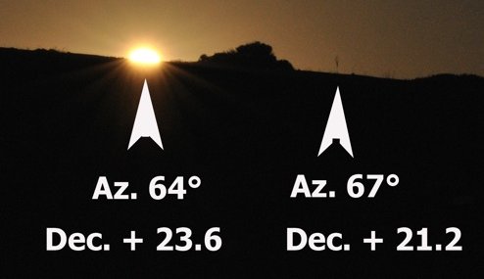
Figure 4. Picture taken from Mnajdra South Temple, showing the position of sunrise close to SSSR, and the position of a marker placed on the posthole which is 3º of azimuth off the SSSR position.

This precise constructional symmetry might obviously draw the attention to an intentionality of solar alignments at specific times throughout the year. MNS was first excavated in 1840, but old photos taken before clearing and restoration works, indicate a ‘general sense of disorder’ (Pace 2004b:127). On the other hand, according to Evans (1971: 96) the ‘irregularity of the uprights gives the whole façade an archaic look which is belied by pottery evidence’ and he further refers to the entrance corridor as ‘well preserved’. Based on these observations, it can be argued that the entrance, the central corridor and the façade of MNS might still be in their original architectural layout and, as mentioned earlier in this paper, that rooms 2, 3 and 4 might have been an earlier free standing temple. Based on such an argument, orientation measurements were conducted from room 3, as this paper will argue that it might have been the very first constructional part of MNS. With the aid of a hand held compass, three possible alignments towards the rising of the sun were manifested. From the very center of room 3 in front of the altar slab, through the center of the porthole entrance an azimuth about 63° was measured, which is oriented to the SSSR. (see red lines in Fig.1). Measuring from the edge of the north side of the same altar through the middle of the entrance, shows an azimuth of 92°, directed towards the Equinox and the heliacal rising of Pleiades during the temple period. The third measurement was of azimuth 120° and the WSSR, taken from the center of the altar table in the north niche through the temple entrance in a cross-jam view. Without the present temple façade, an offset illumination of the central areas of this altar would probably have been illuminated at sunrise during equinoxes and the summer and winter solstices. That room 2 has a central axis of Az. 92.7° and aligned to the equinox sunrise has been firmly established both by calculation (Fodera Serio et al. 1993: 172) and by survey observations (Cox and Lomsdalen 2010; Campion and Malville 2011: 360-1). Alignments to celestial bodies cannot overrule archaeological chronology, nevertheless, as noted before, several archaeologists believe that rooms 3 and 2 and possibly 4 could have been the very first parts of the construction. Based on such an assumption, the temple architects might have developed a progressive interest and knowledge of horizon astronomy and the movements of the celestial bodies in relation to the illumination of demarcated areas of their temples. As suggested by both Cox and Ventura, it might not be the actual equinox sunrise the early temple builders were interested in, but actually the Pleiades. The placement of the temple in relation to a clearly defined eastern horizon at a distance of about 400 meters, with an horizon altitude of about 4°, could also suggest an intentionality for horizon astronomy exposure. This study observed another two orientations towards the rising of the sun in MNS. As mentioned earlier, room 1 has two seeming oracle holes build into the apse wall. The oracle hole in room 5 has a diagonal azimuth of about 63°, oriented towards the SSSR. Oracle hole from room 6, has a diagonal azimuth of 120°, directed towards the WSSR (Fig. 1, blue lines). These alignments have to be further studied in more detail than this paper allows. A counter-argument might be that there is no problem finding objects that have alignments or orientations to wherever one wishes, which might be true in its own context. Nevertheless, by finding a series of alignments from different positions within a temple compound directed towards the same astronomical events, it could be argued that not only did the temple builders watch the cyclic arc of the sun, but might also intentionally construct the temple accordingly.

Conclusion
Given the evidence here presented, the architectural structure of the MNS is undoubtedly oriented towards the arc of the rising sun throughout the year and could indicate a device for framing time and seasons. Based on observations and studies at the Spring Equinox and the Summer and Winter solstices, the MNS temple has an orientation towards the East. The sunrise alignments in question illuminate specific areas of the temple which may have had sacred connotations, indicating their use in implementing religious rituals and sun worshipping. For modern man, these specific sunrise alignments and observations herald the beginning of a new cycle of the seasons of the year. Nevertheless, to conclude that the Mnajdra South Temple was intentionally constructed as a solar calendar or a device to keep track of time, requires further thought and research. Retrieved artifacts have been useful in establishing an anthropological picture of the Neolithic Maltese’s pattern of social behavior, religious and cultural perceptions, as well as cosmological awareness and orientation. Nevertheless, there remain more questions than answers regarding the Maltese temple period: who were the builders, how the temples came about, what was their intent and purpose and why it inexplicably ended abruptly, without leaving any evidence other than the structures themselves.

References
Abela, Franscesco, 1647. Malta Illustrata: Della Descrittione di Malta, Malta, Paolo Bonacota, Facsimile Edition 1984 by Midsea Books Ltd.
Agius George, Ventura Frank 1980. Investigation into the Possible Astronomical Aligments of the Copper Age Temples in Malta, Malta, University Press.
Albrecht Klaus, 2004, Maltas Tempel: Zwischen Religion und Astronomi, Wilhelmshorst, Naether-Verlag.
Bonanno, Anthony, 2005. Malta Phoenician, Punic and Roman, Malta, Midsea Books.
Bonanno, Anthony, 2011. The lure of the islands: Malta's first Neolithic solonisers. In: PHOCA-COSMETATOU, N. (ed.) The first Mediterranean islanders: initial occupation and survival strategies. Oxford: University of Oxford School of Archaeology.
Campion, Nicholas, 2008. The Dawn of Astrology: A Cultural History of Western Astrology, London, Continuum.
Campion Nicholas, Malville J. McKim 2011. Masters-level education in archaeoastronomy at the Univesity of Wales Trinity Staint David. In: RUGGLES, C. L. N., ed. Archaeoastronomy and Ethnoastronomy: Building Briges Between Cultures, January 5-14, 2011 Lima, Peru. Cambridge: Cambridge University Press, 357- 63.
Cox, John. 2001. The Orientations of Prehistoric Temples in Malta and Gozo, Archeoastronomy, xvi, 24-37.
Cox John, Lomsdalen Tore. 2010. Prehistoric Cosmology: Observations of Moonrise and Sunrise from Ancient Temples in Malta and Gozo Journal of Cosmology, Vol. 9, 2217-2231.
Cilia, Daniel (ed.), 2004. Malta before History: The World's Oldest Free-Standing Stone Architecture, Malta, Miranda Publishers.
Evans, J. D., 1971. The Prehistoric Antiquities of the Maltese Islands: A Survey, London, The Athlone Press University of London.
Frank Ventura, Giorgia Fodera Serio, Michael Hoskin. 1992. The Orientations of the Temples of Malta, Journal for the History of Astronomy xxjii, 107-119.
Giorgia Fodera Serio, Michael Hoskin, Frank Ventura. 1993. Possible Tally Stones at Mnajdra, Malta, JHA, xxiii.
Grima, Reuben. 2001. An Iconography of Insularity: A Cosmological Inerpretation of some Images and Spaces in the Late Neolithic Temples of Malta., Institute of Archeology, vol 12, 48-65.
Malville, J. McKim, Schild, Romauld, Wendorf, Fred, Brenner, Robert, 2008. Astronomy of Nabta Playa. In: HOLBROOK, J. (ed.) African Cultural Astronomy - Current Archaeoastronomy and Etnoastronomy Research in Africa. Springer.
Malville, J. McKim 2011. Astronomy and ceremony at Chankillo: an Andean perspective. In: RUGGLES, C. L. N. (ed.) Archaeoastronomy and Ethnoastronomy: Building Bridges between Cultures. Cambridge: Cambridge University Press.
Kolb, Michael J., 2008. The Genesis of Monuments among the Mediterranean Island. In: E. BLAKE, A. B. K. (ed.) The Archaeology of Mediterranean Prehistory. Oxford: Blackwell Publishing.
Magli, Giulio, 2009. Mysteries and Discoveries of Archaeoastronomy From Giza to Easter Island, New York, Copernicus Books.
Pace, Anthony, 2004a. The Building of Megalithic Malta. In: CILIA, D. (ed.) Malta Before History. Malta: Miranda Publishers.
Pace, Anthony, 2004b. The Sites. In: CILIA, D. (ed.) Malta before History. Malta: Miranda Publishers.
Portal, Naval Oceanographic. Data Service [Online]. USA: USNO. [Accessed 2010-11].
Renfrew, Colin, 2007. Prehistory: The Making of the Human Mind, London, Phoenix.
Ridley, Michael, 1976. The Megalithic Art of the Maltse Island, Poole, UK, The Dolphine Press.
Ruggles, Clive, 1999. Astronomy in Prehistoric Britain and Ireland, London, Yale University Press.
Ruggles, Clive 2010. Heavenly Power in Worldly hands: Ancient Sky Perceptions and Social Control. Public Lecture. Gilching, Germany: European Society for Astronomy in Culture (SAEC).
Schmidt, Klaus, 2008. Sie Bauten die ersten Tepel: Das rätselhafte Heiligtum der Steinzeithäger., München, Deutscher Tascenbuch Verlag.
Skeates, Robin, 2010. An Archaeology of the Senses, Oxford, Oxford University Press.
Tilley, Christopher, 2004. The Materiality of Stone: Explorations in Landscape Phenomenology: 1, Oxford, Berg.
Trump, David H., 1972. Malta: An Archaeological Guide, London, Faber and Faber Ltd.
Trump, David H., 1997. Malta: An Archaeological Guide, Malta, Progress Press.
Trump, David H., 2002. Malta Prehistory and Temples, Malta, Midsea Books.
Vassallo, Mario. 2000. Sun Worship and the Magnificent Megalithic Temples of the Maltese Islands, The Sunday Times of Malta.
Vassallo, Mario. 2011. Hagar Qim's layout shows yearly movements of the sun, The Sunday Times of Malta.
Ventura, Frank, 2004. Temple Orientations. In: CILIA, D. (ed.) Malta Before History. Malta: Miranda Publisher.
Zammit, Themistocles, 1929a. Malta: The Islands and their History, Valletta, The Malta Herald
Zammit, Themistocles, 1929b. The Neolithic Temples of Hal-Tarxien – Malta, Vallettta, Empire Press.

Acknowledgments
A sincere thanks and gratitude to all the following who have been involved in, supportive and contributing to this field study: Dr. Nick Campion, Clive Cortis, John Cox, Dr. Reuben Grima, Prof. Kim Malville, Saviour Sacco, Dr. Fabio Silva, Mario Vassallo and Prof. Frank Ventura. Furthermore I am deeply grateful to Dr. Mario de Marco, Minister of Tourism, Culture and Environment and Heritage Malta for giving me access to the temples.

